What Is Networking
DG Interns Hub | Week 1 | TryHackMe Room Writeup

Objective
Understand why computer networks are used and how devices communicate.

Activity summary
Reviewed introductory networking tasks and answered room questions.

Key learning
Networks, communication and basic network devices.

Evidence
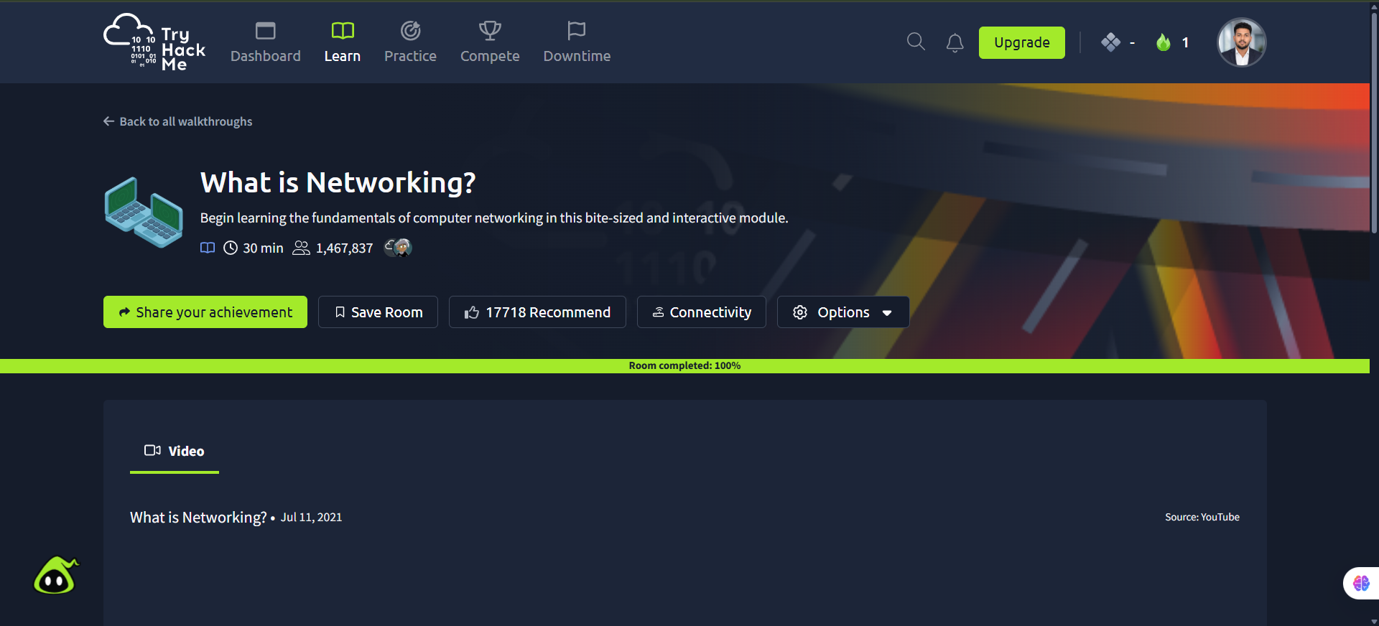
Screenshot: _What_Is_Networking.png
Completion screenshot provided; the original step-by-step room answers were not included in the archive.

